Logging into Canvas to sign up for your course
The FIRST time you register:
- Go to: Canvas.instructure.register
- Select “I’m a student.”
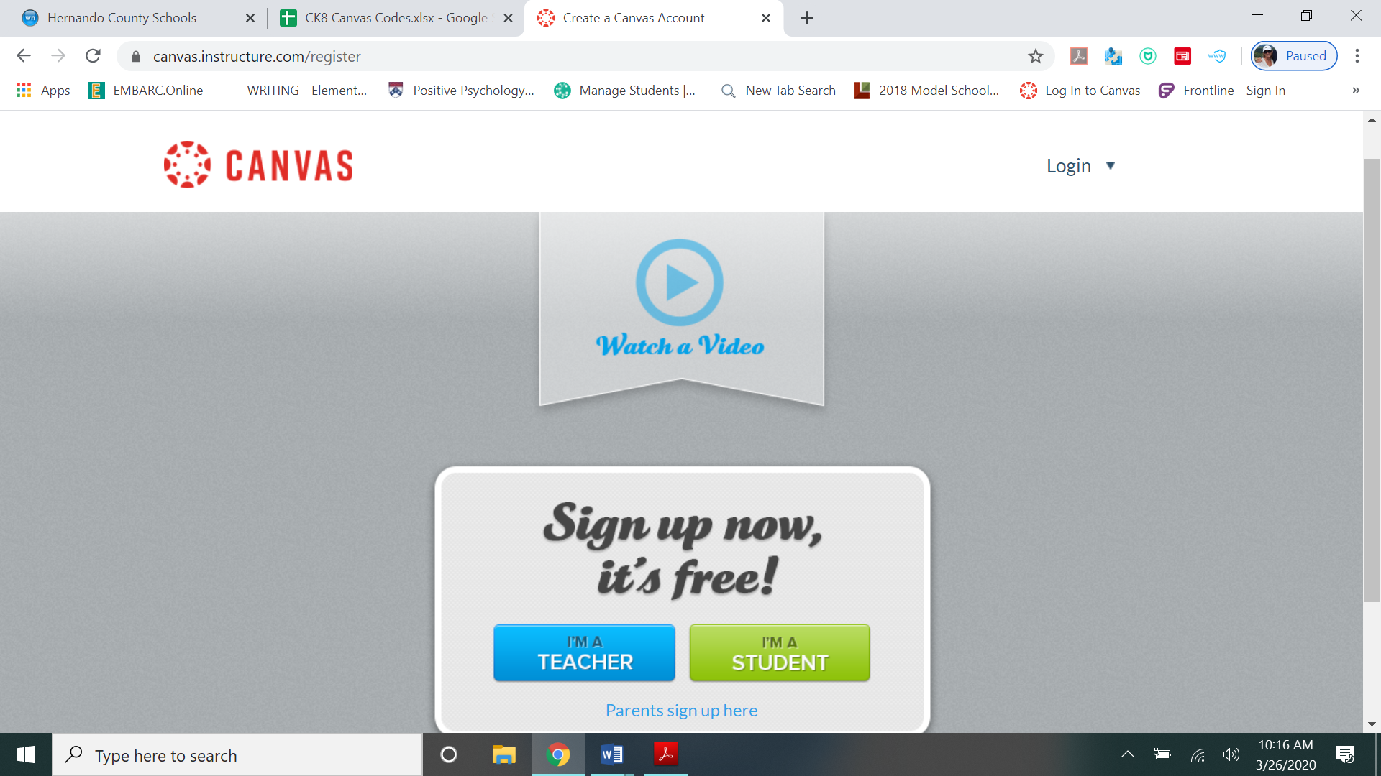
- Enter the code you received from your teacher.
- Enter your full name.
- Create a user ID. *This should be your first and last name. For example, sallyjones
- Create a password. *Password must be a minimum of 8 characters long. Write it down so that you will not forget what it is.
- Check that you agree to the terms and enroll
- Make sure you record your username and password somewhere safe

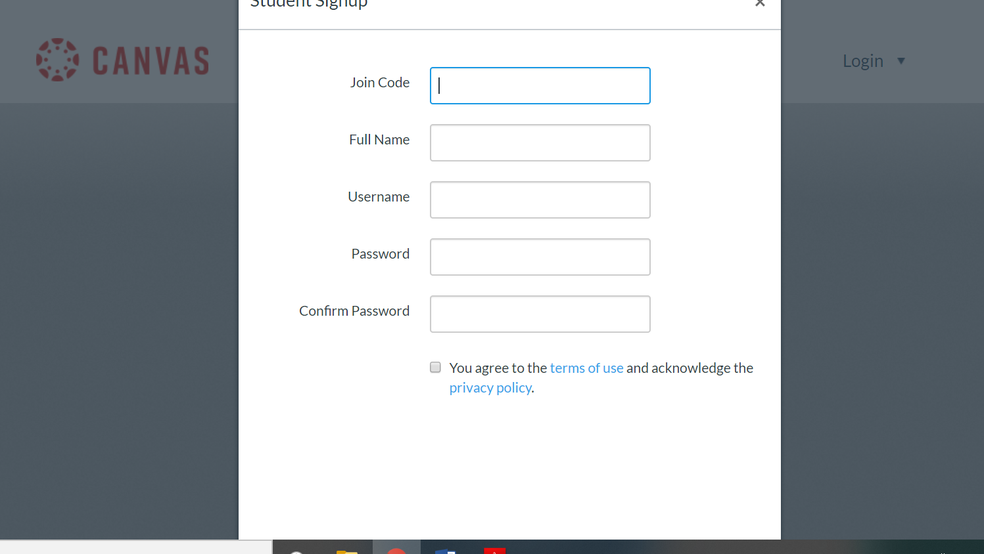
To log back into Canvas:
You do NOT need to use an email address.
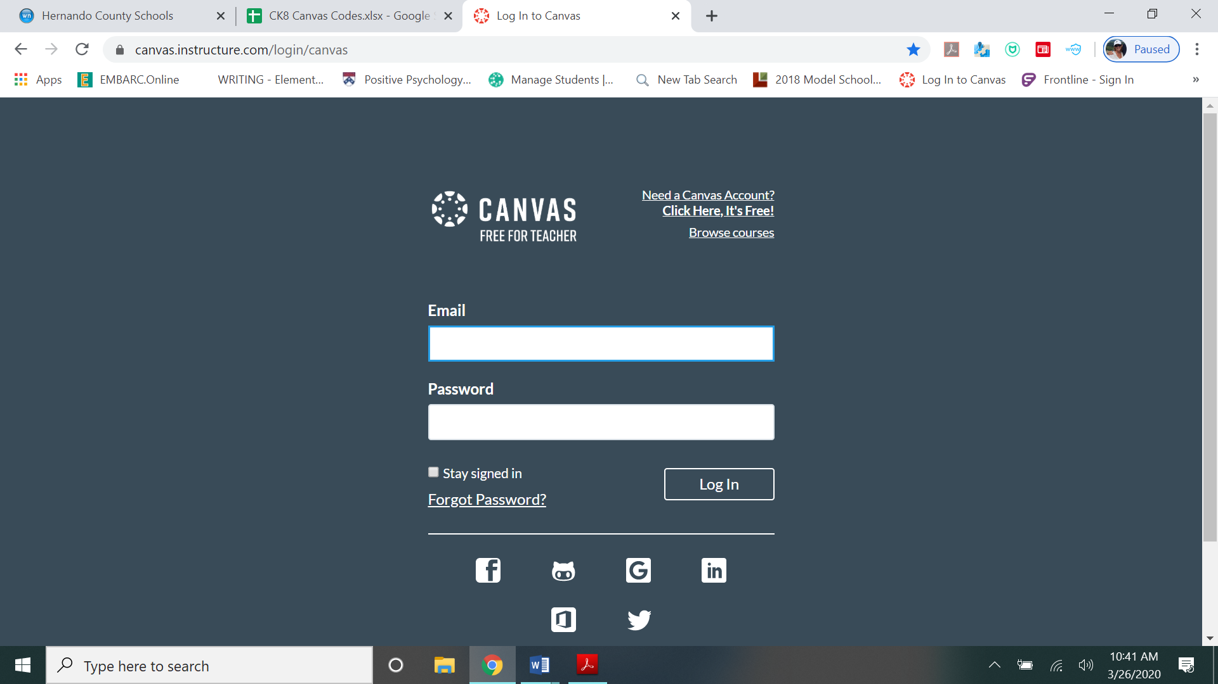
You will use the User ID and password that you created the first time you created your canvas account.

To register an ADDITIONAL code:
*repeat this portion for all of the codes you receive

Log into Canvas at canvas.instructure.com, using the User ID and password that you created.
Change the web address to say canvas.instructure.com/enroll/###### (replace the ##### with the additional code you have received and push enter.)
Then click on courses on the left toolbar and then all courses.
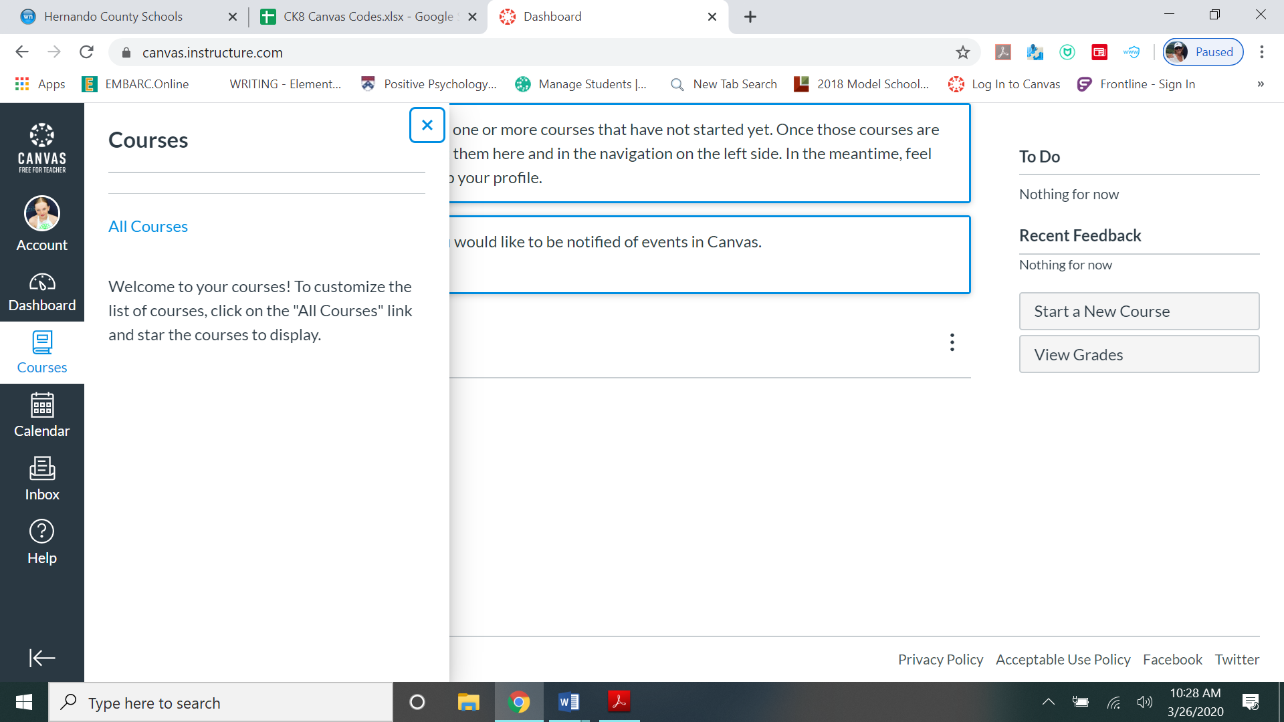

You should now see all courses that you have enrolled in. You will not be able to click into the course unless your teacher has published the course.
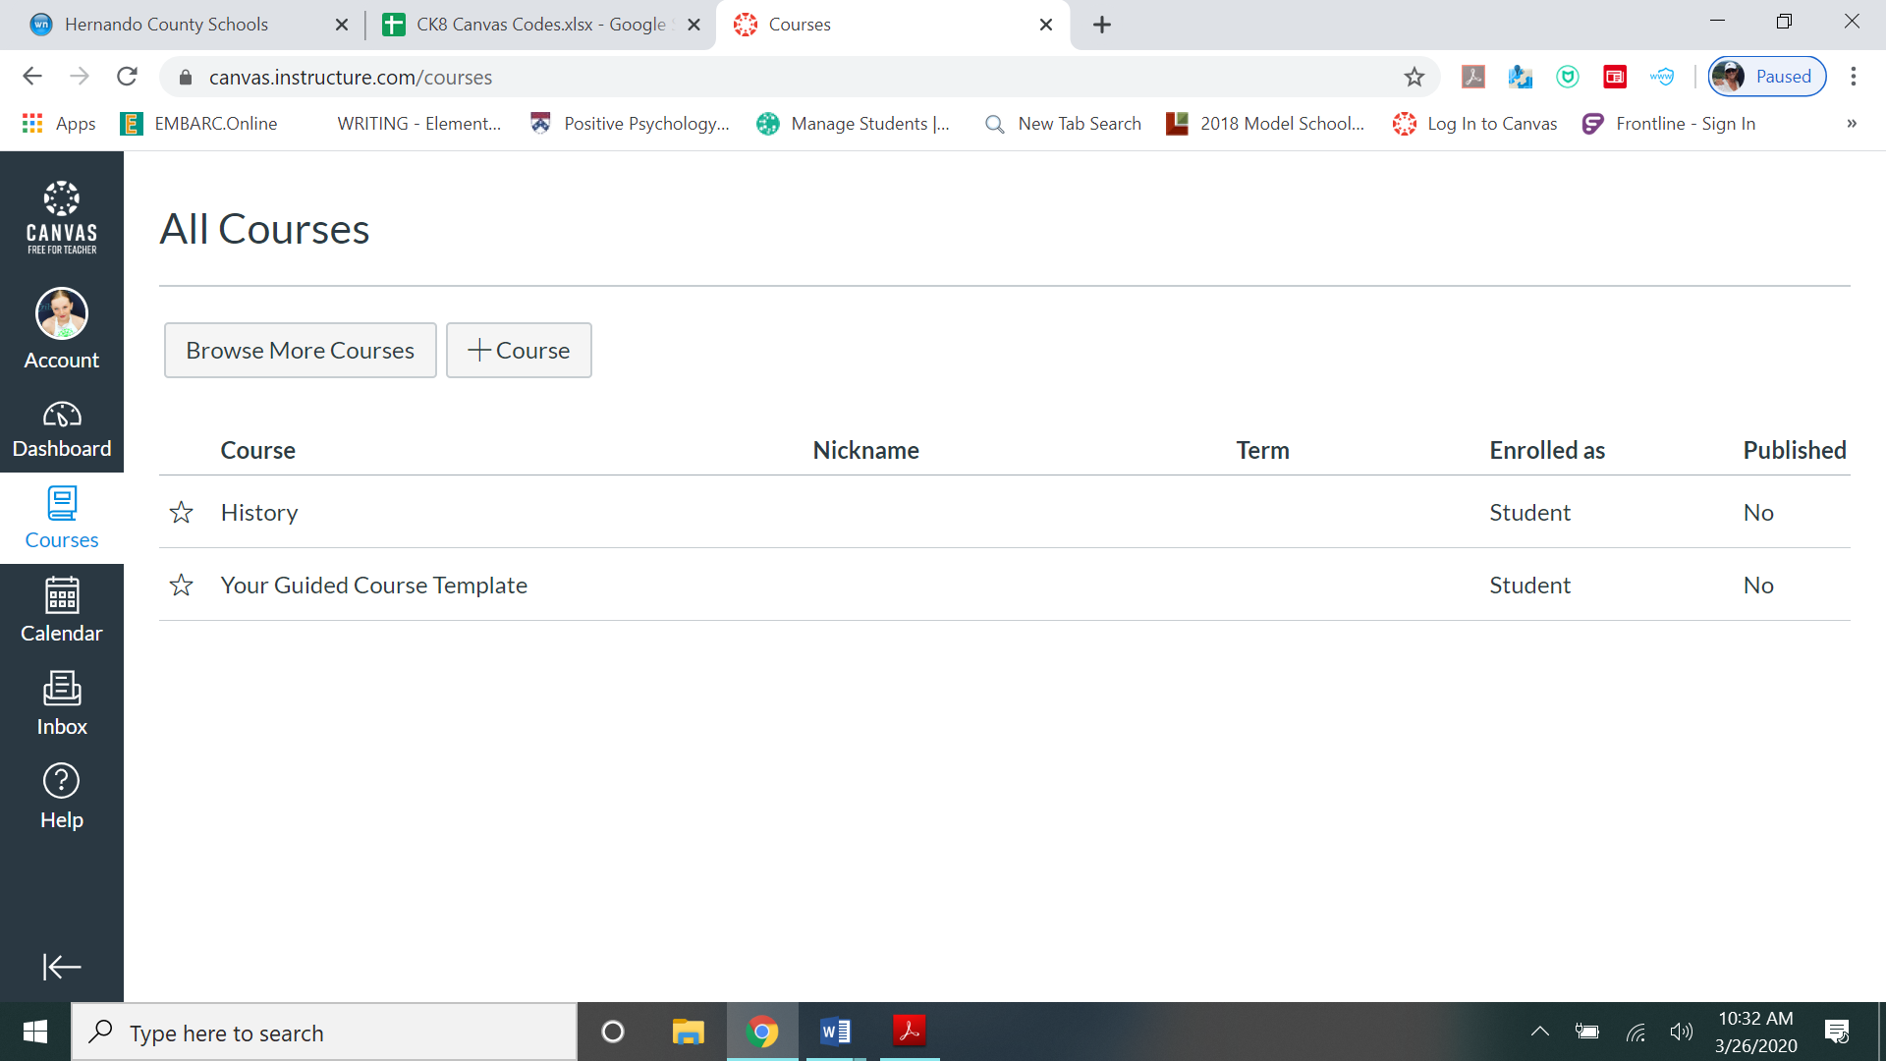
***Helpful hints***
You are not able to use the Canvas app on your phone, as we are using the “free” version of canvas and the app only supports the paid version.
If you have followed the steps and are still having trouble please contact: __________________________

